Note : If device is powered by battery , please confirm the battery value must bigger than 0x32(50%), otherwise it will ota fail .

- After Click PC and then select Home
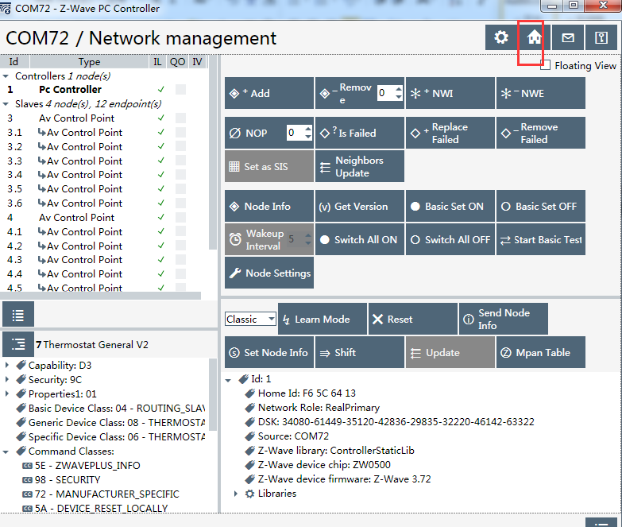
- Select OTA button
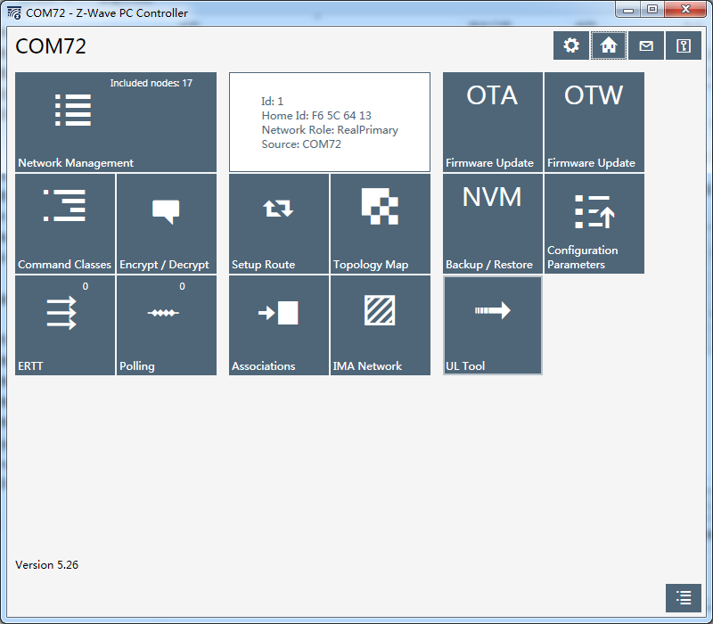

- Select device what you want to OTA (As below , my device NodeID is 07 ), and then send Get command to know current version
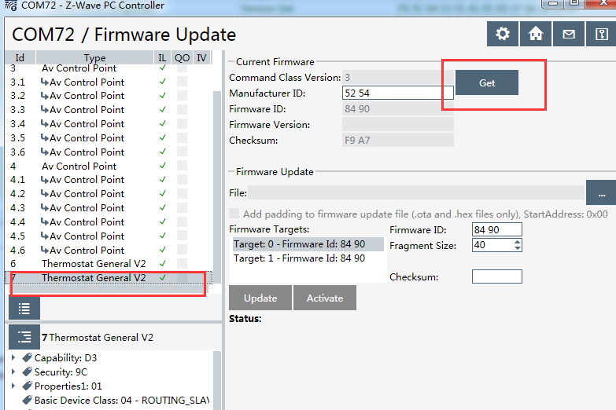

Below is the example for OTA MCU :
(if you want to ota Zwave , please select the correct target and the file )

- Click the file selection and get mcu OTA file
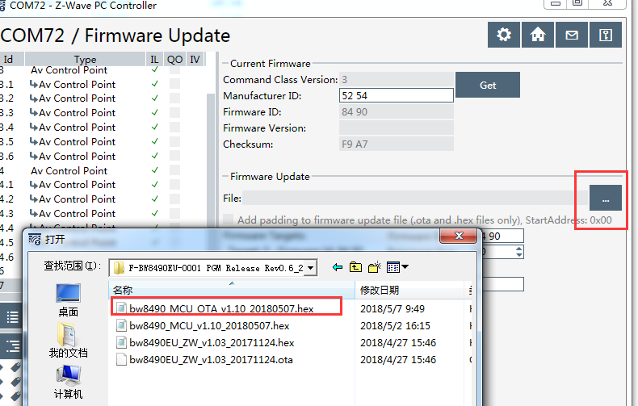
- Select the target（Target0:Zwave Target1: MCU）
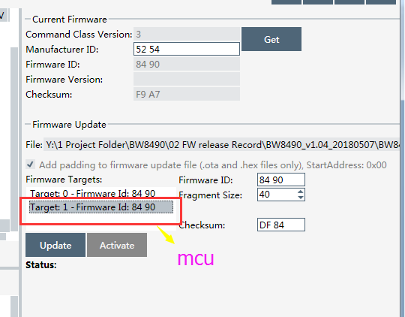
- After select Firmware Targets, click Update button and it begins to update（Duration of ota , the green led begin to flashing）
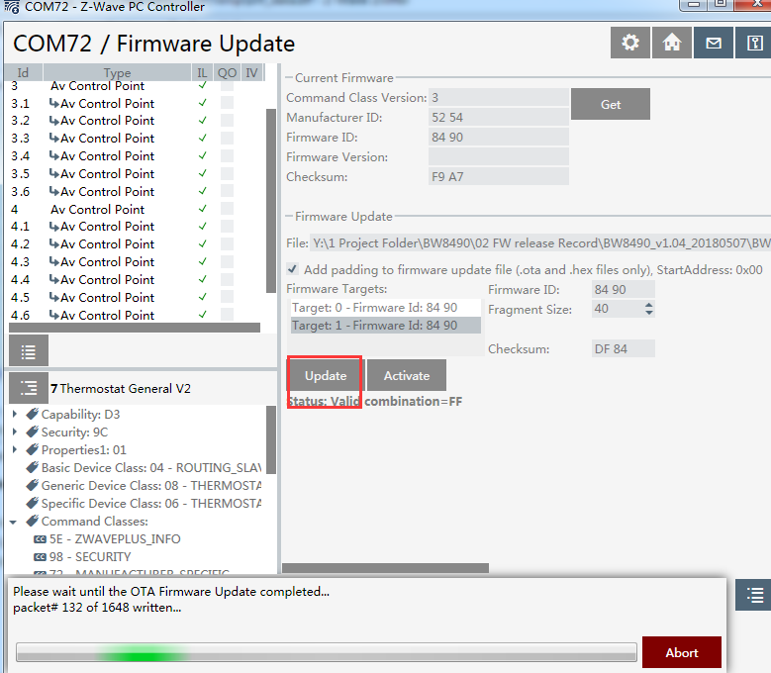
- After OTA finish , you must wait until the led stop flashing and then double click Version command to confirm the version
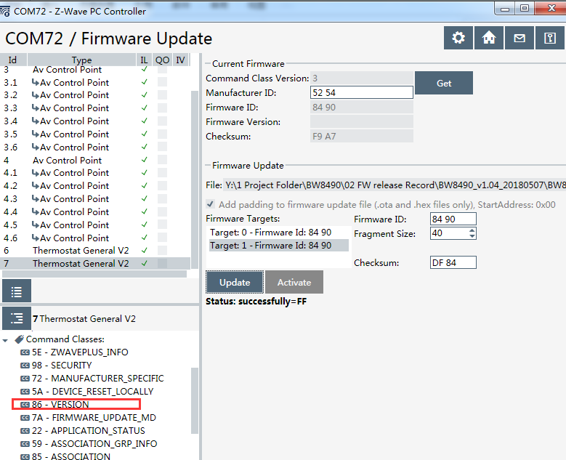
- Please confirm the version:
